It’s Time for a Progressive Reading of the Constitution
Conservatives have claimed the moral high ground of so-called originalism. Liberals need to put forward their own vision.

Erwin Chemerinsky
Following
For five decades, conservatives have claimed the moral high ground in judicial matters, claiming that they are simply interpreting the Constitution as it was written by our Founding Fathers — what they call an originalist approach. But conservative justices’ decisions are no less shaped by their worldview than progressives’.
- In 2008, for instance, for the first time in U.S. history, the five conservative justices on the Roberts court declared a local gun control ordinance to be unconstitutional — a violation of the Second Amendment.
- In 2010, these same justices found that corporations have the right to spend unlimited amounts of money in election campaigns.
- In 2013, they invalidated a federal civil rights law in the area of race — a key provision of the Voting Rights Act of 1965 — for the first time since the 19th century.
By any measure, all these cases were based on the ideology and values of the conservative Republican justices, not the text or the original meaning of the Constitution. It is laughable to say that the framers of the First Amendment intended that corporations should be able to spend unrestricted sums from their campaign treasuries to get candidates elected or defeated. Those who wrote the First Amendment did not envision campaign spending as it exists today, let alone modern corporations. Additionally, each decision-overruled precedent invalidated a law that was enacted with overwhelming support, broadly decided a matter when a narrow ruling was possible, and did so to advance conservative political values.
It’s time for progressives to fight back by offering an alternative vision of constitutional interpretation and constitutional law based on fulfilling the Constitution’s promise of liberty and justice for all. Progressives need to expose how conservatives are using the Constitution to advance their own agenda, which favors business over consumers and employees and government power over individual rights.
The place to start is at the very beginning, with the Preamble, which articulates the purposes for the document.
The first step must be to refute the conservatives’ legal notion of “originalism,” whereby all constitutional issues, including such controversial questions as the death penalty or affirmative action, can be resolved based solely on the original text of the Constitution and its meaning at the time it was written. Conservatives maintain that this allows justices to decide cases without imposing their own values. That is nonsense. There is no such thing as “value-neutral judging.” It is a myth that conservatives have advanced for decades and continue to espouse for their own purposes.
But it is not enough to reveal the conservatives’ false promise of judicial neutrality. Progressives must offer their own vision for what the Constitution should be understood to mean. The document should be interpreted to fulfill its central values. Therefore, it is essential to begin by identifying the core underlying values that the Constitution is meant to achieve. The place to start is at the very beginning, with the Preamble, which articulates the purposes for the document. The Preamble states: “We the People of the United States, in Order to form a more perfect Union, establish Justice, insure domestic Tranquility, provide for the common defence, promote the general Welfare, and secure the Blessings of Liberty to ourselves and our Posterity, do ordain and establish this Constitution for the United States of America.”
Unfortunately, the Preamble has been largely ignored in Supreme Court decisions and scholarly writings. It has been treated as a mere rhetorical flourish to the Constitution. But, on the contrary, it is much more: It provides a lens through which the Constitution can be examined, articulating the basic values of the document that follows.
I, of course, am not making an argument that I know the intent of the framers of the Constitution in these areas. Their intent cannot be known and should not limit contemporary constitutional law. The Constitution must be adapted to the problems of each generation; we are not living in the world of 1787 and should not pretend that the choices for that time can guide ours today. Chief Justice John Marshall expressed this realization almost 200 years ago when he said that “we must never forget that it is a Constitution we are expounding,” a Constitution “meant to be adapted and endure for ages to come.”
Given Donald Trump’s election, it is not likely that my vision will be adopted in the immediate future. But that’s not the point. Conservatives, in their think tanks and Federalist Society cliques, have spent years articulating and elaborating a conservative vision of constitutional law and the role of the Supreme Court. They did this even during years when conservatives were out of power. Liberals may have thought it futile to create a different and progressive vision with conservative justices in the majority on the Supreme Court for the past 45 years. Perhaps, too, progressives have been wedded for too long to the Warren court’s vision and not thought enough beyond it. The Warren court ended almost a half-century ago, in 1969, and it made huge strides in ending segregation and expanding the rights of criminal defendants. But now is the time to provide and defend and fight for an alternative, grander, and more inclusive interpretation of the Constitution.
The Preamble to the Constitution clearly states the values that the document is meant to achieve:
- ensuring democratic governance,
- providing effective government,
- establishing justice, and
- securing liberty. Added to these values should be
- furthering equality,
not something that was mentioned in the Preamble to a Constitution which protected the institution of slavery.
There is much that progressives can fight for to fulfill each of these values. We need to create an election system that is far more democratic, including ending partisan gerrymandering, lessening the likelihood that the Electoral College will choose presidents who lose the popular vote, and combating disenfranchisement of minority voters.
Establishing justice requires finally eliminating the death penalty, which is inflicted in an arbitrary and racially discriminatory manner. There must be a better system of ensuring that those who are accused of crimes have competent counsel.
Securing liberty requires that there must greater constitutional protection of privacy. This includes more safeguards against government intrusions, better protection against information gathering by the government, and continued protection of basic aspects of autonomy, including reproductive autonomy.
Looking at the Constitution in a progressive way would produce a very different approach, one that would do much more to provide liberty and justice for all. In most areas, it would not take more than the shift of a single justice to create decisions pointing constitutional law in a fairer direction that does much more to realize the promise of the Preamble and the Constitution. Maybe the unexpected will happen and there will be a progressive majority on the Supreme Court sooner than I or anyone expects. If not, some changes can be accomplished through legislative action at the federal or state levels; much can be done under state constitutional law when the Supreme Court and federal courts do not act.
It is so tempting to look at the composition of the Supreme Court as a historic inevitability. But in reality, it is a product of coincidences between the timing of vacancies and who is in the White House. If Hubert Humphrey rather than Richard Nixon won in 1968—and it was a very close election—then a Democratic president would have picked four new justices between 1969 and 1971, and that would have continued a liberal majority on the court for decades more. If Al Gore or John Kerry had been president in 2005, when William Rehnquist and Sandra Day O’Connor left the Supreme Court, there would be five justices appointed by Democratic presidents on the court today, notwithstanding the election of Donald Trump, the appointment of Neil Gorsuch, and the resignation of Anthony Kennedy. If Hillary Clinton had been elected president — and she did win the popular vote by 3 million votes — and had replaced Antonin Scalia, the next years and perhaps decades of constitutional law would be vastly different.
So I think it is important to step away from the current composition of the Supreme Court and focus instead on what should be the meaning of the Constitution itself. How should progressives interpret this majestic but flawed document? The Constitution, and how it is interpreted, affects all of us, often in the most intimate and important aspects of our lives. It should be interpreted to create a nation where there truly is liberty and justice for all.

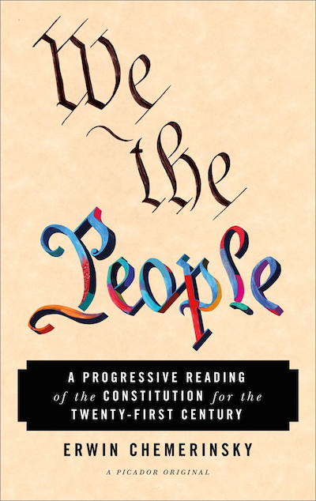

From WE THE PEOPLE: A Progressive Reading of the Constitution for the Twenty-First Century by Erwin Chemerinsky. Published by Picador. Copyright © 2018 by Erwin Chemerinksy. Reprinted by permission of Picador, an imprint of Macmillan Publishers. All rights reserved.

WRITTEN BY

Erwin Chemerinsky

Erwin Chemerinsky is the 13th Dean of UC Berkeley, School of Law and the Jesse H. Choper Distinguished Professor of Law.

